**Columbia Brotherhood Lodge No. 370**



Free and Accepted Masons

### 855 Brotherhood Way, San Francisco, CA 94132

**V O L U M E 1 2 0 , I S S U E 10 O C T O B E R 2 0 2 5**

|

**T H I S M O N T H**

**O C T O B E R**

**OCTOBER 1**

* **STATED MEETING**

**OCTOBER 13 & 27**

* **MASONIC FORMATION CLASS**

**OCTOBER 16**

* **DSOI HOSTED BY SF120**

**OCTOBER 18**

* **BLACK & WHITE BALL**

**OCTOBER 22**

* **OFFICER PROFICIENCY PRACTICE**

**OCTOBER 24 -26**

* **CA GRAND LODGE ANNUAL COMM MTG**

**OCTOBER 29**

* **DEGREE CONFERRAL**

**N O V E M B E R**

**NOVEMBER 5**

* **STATED MEETING**

**NOVEMBER 10 & 24**

* **MASONIC FORMATION CLASS**

**NOVEMBER 12**

* **INSTALLATION PRACTICE**

**NOVEMBER 18**

* **DSOI HOSTED BY CAL 1**

**NOVEMBER 19**

* **DEGREE CONFERRAL**

**OCTOBER 22**

* **OFFICER PROFICIENCY PRACTICE**

**OCTOBER 24 -26**

* **CA GRAND LODGE ANNUAL COMM MTG**

**OCTOBER 29**

* **DEGREE CONFERRAL**

**S A V E T H E D A T E**

**DECEMBER 13**

* **OFFICER INSTALLATION**

[**WWW.CBL370.COM**](http://WWW.CBL370.COM/)

From the East

Brethren and Friends,

As we prepare for our literal and figurative harvests for this year, I send you greetings from the East.

The fall season is that time of year when many look forward to a harvest of that which they have been cultivating, a time to reap what has been sown, but what are clear indications that that which has been cultivated is ready to be harvested. As Masons we are continually using the tools of our ancient Operative brethren while sowing the seeds of goodwill on our path to becoming the best we can be, but how do we gauge

b

***Worshipful Master, Anil Awasti***

our progress? What metrics do we use to determine our progress at becoming the best person each of us can be? One possible metric is how we interact with others and how we make others feel. After we engage with others, do they leave the experience with a feeling of being heard, loved and respected even when it was a difficult conversation? Do they look forward to or dread future? Using Temperance, Fortitude, Truth and Justice to counter the behaviors of our internal ruffians thereby freeing ourselves to use the trowel to spread the cement of Brotherly love and affection uniting us as brothers and friends, to be conscious of that which provides relief,

to come from a place of truth and being truthful in our interactions.

These behaviors assist us on meeting each other on the level, Acting upon the plumb and being the plumb

To put it simply, the plumb reminds Freemasons to adhere to the strict moral standards required to build a life of virtue. It serves as a guiding principle, encouraging Brothers to remain steadfast in their commitments, regardless of challenges or circumstances. At its core, the Plumb Rule serves as a reminder for Masons to act with honesty and integrity in all aspects of their lives. Just as the tool ensures that the building is constructed

*Continued on Page 4.*

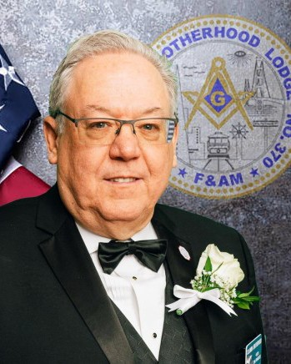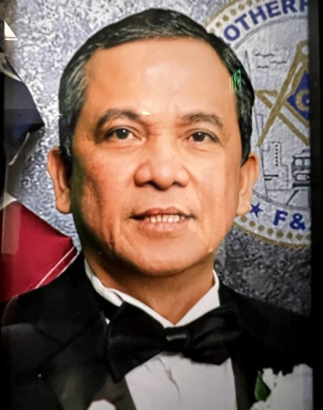

|

From the West

***Senior Warden, Bruce Lyons***

Hello Brothers, family, and friends:

Hope your summer has been fun and relaxing, and your kids are ready to start the new school year. Time flies and before you know it, the holiday season will be upon us.

August saw two MFC classes conducted by our class leader and head coach WB James Gonzalez. The class is going strong, and I see some future Masters and officers coming from the class. Come and join one Monday night and impart some of your knowledge to the new guys. We would love to have you. Our prospects are always

interested in meeting more masons and learning from them.

|

We did not have a degree in August, but we do expect to raise Brother Corey Dussault to the sublime degree of Master Mason in September. And we hope to have other conferrals soon.

In a recent search for an article about our principles of Freemasonry, I happened upon a website, [MasonicFind.com: Masonic Knowledge & Community](https://masonicfind.com/). This is a community of Masons who contribute to the site to further a brother’s masonic journey and allow for non-masons to learn more about our craft. I suggest you consider

visiting the site to learn a little more about Free-masonry and improve your adventure. One article that I enjoyed was entitled **“The 3 Core Principles of Freemasonry: An Explanation**.” **#1 Brotherly Love:** This doesn’t just mean being kind to your fellow man but also includes developing a deep and lasting bond with your fellow Masons. This is done by treating each other with respect, lending a helping hand when needed, and being there for one another in good and bad times. One of the best ways to practice brotherly love is by being an active member of our lodge. Get to know your fellow Masons and build lasting relationships with them. Also, look for ways to help our lodge and the community it

*Continued on Page 5.*

From the South

Greetings Brethren

I hope everyone is enjoying the summer. Time really flies as it is the “Ber” month again.

For the September stated meeting, we will dine on cornflake chicken or salmon or a vegan option. I encourage all brothers to attend our stated meeting and other events.

The Hiram award will take place at Columbia Brotherhood lodge on September 6. Join us to congratulate our Worshipful

***JUNIOR WARDEN, FRANK B. PERTIERRA***

Brother James Gonzalez. On September 19th. WB Rick Smith will chair the Night at the Opera. Unfortunately, we only have limited tickets. The Past Masters Ball will take place at our lodge on September 27. An elegant evening featuring excellent food and lively dancing, chaired by WB Donnie Dela Cruz.

We had few events last August. Thank you to the organizers for the Giants Game led by Brother Jimmy Fowler. It was a relaxing and fun day with the brothers and sisters. Also, thanks go to

Brother Jerry Jugal for chairing the Inter lodge picnic with San Francisco 120 at Twin Pines Red-wood picnic area in Belmont.

Please join us for the September events and make your reservations early through sign-up genius or email me at [fbpertierra@aol.com](mailto:fbpertierra@aol.com) or text me at 707-342-8770. I hope to see you all there.

Fraternally,

Frank B. Pertierra Junior Warden

**2025 LODGE OFFICERS**

Anil Awasti (Manisha) ………….................... **MASTER**

(415) 846-7129

Email: [awastianil@gmail.com](mailto:jason@hui.cc)

Bruce Lyons ….………………………………… **SR. WARDEN**

(415) 309-0495

Email: [bruce@coastalpacificins.com](mailto:awastianil@gmail.com)

Frank Pertierra (Roselle) ..………………… **JR. WARDEN**

(707) 342-8770

Email: [fbpertierra@aol.com](mailto:fbpertierra@aol.com)

Reyno Del Rosario, Jr., P.M (Jen)………. **TREASURER**

(925) 642-2717

Email: [reyowen@yahoo.com](mailto:Orlando@jetintl.com)

Jason Yen, P.M*. (Sunny) …………………….. **SECRETARY**

(925) 989-6898

Email: [jasonyen@cbl370.com](mailto:jasonyen4270@hotmail.com)

Jason Hui, P.M. (Roxana) ……………………. **CHAPLAIN**

(415) 300-0911

Email: [jason@hui.cc](mailto:jason@hui.cc)

Jimmy Fowler ………………………………….. **SR. DEACON**

(415) 530-9779

Email: [jaf1331@yahoo.com](mailto:fbpertierra@aol.com)

Jod’l Cruz (Jem) ……………………………….. **JR. DEACON**

(707) 631-8001

Email: [jodljaycruz@gma](mailto:jerryjugal70@gmail.com)il.com

Jeremias Jugal ……………………………………. **MARSHAL**

(707) 334-8549

Email: [jerryjugal70@gmail.com](mailto:jerryjugal70@gmail.com)

Jose Rivera (Maria) ……………………….. **SR. STEWARD**

(408) 234-4609

Email: [medusklein5@gmail.com](mailto:medusklein5@gmail.com)

Patrick Cheng (Diana)……………………… **JR. STEWARD**

(925) 755-6728

Email: [backdocssf@yahoo.com](mailto:backdocssf@yahoo.com)

Dionisio Dela Cruz, P.M.(Nonie) ………………….. **TILER**

(707) 718-0825

Email: [onnie6219@gmail.com](mailto:onnie6219@gmail.com)

**PROPOSED CHANGE TO BYLAWS**

Pursuant to CMC Section 802.020, this serves as notice to members of the following motion which proposes to increase annual dues from the current $85.50 per annum (which is $25.00 plus the Per Capita sum of $60.50) The proposed text of the motion follows:

“Section 2.The dues of each member of this Lodge shall be the sum of $ (*To Be Determined by a Stated Meeting discussion and a vote of the Members of the Lodge*) per annum, plus the Per Capita sum approved by Grand Lodge at the immediately preceding Annual Communication, payable in advance on the first day of January.”

**2025 COMMITTEES**

**AUDITING COMMITTEE**

Orlando Arce, P.M. ………………………….. (415) 244-5373 Robert De Luzuriaga, P.M. ……………….. (415) 309-7506 James Gonzalez, P.M. ………………………. (510) 772-7415 Augusto Tagaro, P.M. ………………………. (650) 346-4551 Carlos Suncin …………...…………….……….. (415) 806-2711 William Nichols ……………….…....………… (720) 883-2501

**CHARITY COMMITTEE**

Anil Awasti, Worshipful Master ……………...… Chairman Bruce Lyons, Senior Warden ……………………… Member Frank Pertierra, Junior Warde…………………….. Member

**EXECUTIVE COMMITTEE**

Anil Awasti, Worshipful Master

Bruce Lyons, Senior Warden

Frank Pertierra, Junior Warden

Reyno Del Rosario, Jr., P.M. Treasurer

Jason Yen P.M., Secretary

**INVESTMENT-COMMITTEE TRUSTEES**

William F. Aldridge, P.M. … Exp 2026 ……… President Markos Balopoulos, P.M. … Exp 2028 Vice President Mike Balopoulos, P.M. ……. Exp 2029 ……… Member Lawrence Di Giacomo, P.M. Exp 2025 ……….. Member Francis Feliciano, P.M. ……. Exp 2028 ……… Member

Jason Yen, PM …………………………………………… Secretary

**RETENTION & DELINQUENT COMMITTEE**

James Guerrero …………....……………...... (415) 595-9127 Anil Awasti …….……...….……………...……. (415) 846-7129 James Gonzalez ……………………………….. (510) 772-7415

**SCHOLARSHIP COMMITTEE CHAIRMAN**

William F. Aldridge, P.M.………………….(510) 790-8924

**SUNSHINE COMMITTEE**

Ron Ragland, P.M. ……………………...….. (650) 303-9369 Ron Sickler……………………………………….. (650) 464-8717

**HALL ASSOCIATION BOARD**

**RICHMOND MASONIC TEMPLE COMPANY**

James S. Guerrero ……………….. Exp 2026.………. President Jose M. Rivera ……………………… Exp 2026 ………. Secretary Patrick Cheng ………………......... Exp 2027... Vice President Carlos Suncin ………………………. Exp 2027.……….. Treasurer Amelio Feliciano...…….….……… Exp 2027.……….. Member

Gil C. Palencia……………………… Exp 2025………… Member

Anil Awasti, Worshipful Master…………. Ex Officio Member Bruce Lyons, Senior Warden …………….. Ex Officio Member

**INSPECTOR**

Alan Nubla, P.M. (Jacqueline) ………………….. (650) 922.4684 Email: [Allan9128@comcast.net](mailto:Allan9128@comcast.net)

**OFFICERS’ COACHES**

Reyno Del Rosario, Jr., P.M., Officer’s Coach (Jen)

(925) 642-2717

Email: reyowen@yahoo.com

Francis Feliciano, P.M., Assistant Coach (Joy)

(415) 407-0199

Email: djfrance@comcast.net

**TRESTLEBOARD EDITOR**

James Gonzalez, P.M (Mary)…………….. (510) 772-7415

Email: jgonza9916@aol.com

Please remember that no motion can be made during the Stated Meeting unless the Worshipful Master has been properly notified and has included it in the meeting agenda. Failure to do so may cause undue delays and your motion may not be recognized or voted on.

**EDITOR’S NOTES**

Wishing our officers much progress and success at learning the responsibilities and rituals for our upcoming degrees and for the chairs they will occupy during the ensuing Masonic year. Thanks to all who have been participating in our events, and may all our members experience harmony, meaning and satisfaction along their Masonic Journeys.

*Continued From Page 1*

.

Just as the tool ensures that buildings are constructed straight and true, Masons

are encouraged to align their actions with ethical

principles, promoting a life of moral uprightness.

In a parallel _____, What makes a person a mason and why would someone be encouraged to join our lodge? Do we behave in a manner discussed above amongst ourselves? Is our love and comradery apparent for all to see? Do we encourage others who are sometimes subject to decete, untruths, _____ behaviors to show compassion, to behave in a manner which our ancient and honorable fraternity requires.

During the month of September____________

~~Our Lodge held its annual picnic jointly with San Francisco No. 120 on August 30~~~~th~~ ~~at the Twin Pines picnic grounds in Belmont. I thank Brother Jerry Jugal, Brother Jod’l Cruz, WB Dionisio Dela Cruz, Brother Peter Pertierra, and others for putting this event together; and I thank all who participated.~~

~~Masonic Formation Class (MFC) meetings were held on Monday, August 11~~~~th~~ ~~and Monday, August 18~~~~th~~~~. Topics of discussion are listed in the MFC section, below.~~

~~During the month of September, our officers will continue their Advanced Stations Work and some will prepare for the upcoming 176~~~~th~~ ~~Annual Grand Lodge Communications meeting on October 24~~~~th~~~~—26~~~~th~~~~. Other events include the September Stated meeting on September 2~~~~nd~~~~, the Hiram Award presentation on September 6~~~~th~~~~, Masonic Formation Classes on September 8~~~~th~~ ~~and September 22~~~~nd~~~~, a District School of Instruction (DSOI) Meeting hosted by our Lodge on September 17~~~~th~~~~, an Opera event on Sunday, September 19~~~~th~~~~, our annual Past Masters’ dinner dance on Saturday, September 27th, and The 2025 Black and White Ball on Saturday, October 18th.~~

~~On September 6~~~~th~~~~, our lodge will honor Worshipful Brother James Gonzalez with the Hiram Award, the highest honor our Lodge can confer, to celebrating his extraordinary efforts and service to our lodge and to his fellow Freemasons. When our Hiram Award selection Committee shared its recommendation of WB Gonzalez, I was pleased and proud as I have known him since I was a prospect, have worked with him on the Temple Board and on various committees, projects and events, and Served as his Junior Warden. He is always eager to be of service and to assist. I have observed him in and out of the lodge demonstrating a good heart with purity of intentions and promoting virtue. I have also gotten to know Mary, his loving Wife and Partner in life and am grateful for her sup-port of him and therefore of our Lodge. My thanks go out to our Senior and Junior Wardens and our Hiram Award selection committee for their efforts and this well-deserved recommendation. My thanks also go out to Brothers Carlos Suncin and Frank Pertierra for organizing this event. Please join me in as I congratu-late WB James Gonzalez on this well-deserved honor.~~

~~Money concerns which have been expressed during the year and the upcoming increase in the Grand Lodge per capita charges prompt me to raise, for debate, the issue of annual Lodge dues. This conversation is on my agenda for the September Stated meeting, and depending on the outcome of the formal discussion, a dues increase will be voted on as an amendment to our Lodge’s Bylaws.~~

~~My thanks and appreciation go out to our officers for their work on learning next year’s responsibilities and proficiencies; to our Past Masters for their assistance~~

*Continued on Page 5.*

*Continued From Page 4.*

and guidance; to our committee chairs and members for all their efforts associated with the planning and conduct of our discretionary and fraternal events; to all who are planning our September events; and to all of you for your participation.

I look forward to spending time together during the month of September and hold that our behavior will always be within the circumscribed circle bound by the holy writings and the Holy Saints John.

Fraternity yours,

**Anil Awasti,**

**Worshipful Master**

*Continued From Page 2*

serves. Even if you’re not a Freemason, you can still practice brotherly love in your everyday life. Get to know your neighbors and lend a helping hand when needed. You can also get involved in your community and look for ways to make it a better place.

In the next couple of months, I will talk about Relief and Truth. Other important virtues of every Mason. Speaking of Brotherly Love and getting to know your Masonic family, I hope you will start saving your pennies to join the Master’s trip next year in Philadelphia and New York. We will celebrate the 250th anniversary of the signing of the Declaration of Independence. The trip is expected to start on June 29th and go until July 12th. I hope you will make plans to join us. It will be a fun trip for your whole family and a good history lesson.

We would love to share some brotherly love with you, please visit our lodge soon.

With much love and appreciation,

Fraternally,

Brother Bruce Lyons

Senior Warden**IN MEMORIAM**

Thankfully, we have no reports of brothers who have laid down their tools during the past month. For all who have laid down their tools in the past:

*Soft and safe to thee, my brother, be thy resting place.*

*Bright and Glorious be thy rising from it.*

*Fragrant be the acacia sprig that there shall flourish.*

*May the earliest buds of spring*

*unfold their beauties o’er thy resting place,*

*and there, may the sweetness of*

*the summer’s last rose linger longest.*

**BALLOTING**

**Scholarship Committee**

Each one of the thirteen applicants was recommended to receive a scholarship, and our Brother the Treasurer has disbursed the checks to each applicant.

Our Brethren should be grateful for the participant interest and are proud to be able to provide assistance to participants in this system.

**NINA CHAVEZ**

Nina Chavez

**~~(2025 G.M. Decision No. 1)~~**

~~I have been asked to clarify the meaning of the phrase “esoteric or secret portion” of the Ritual as referenced in the~~*~~California Masonic Code~~*~~(“CMC”). Understanding the secrets of Freemasonry is crucial, as each of us has taken an obligation to safeguard them. It is deemed unmasonic conduct to reduce them to writing. To address this question, I have collaborated with the Executive Committee, the Ritual Committee, and the Jurisprudence Committee to develop a comprehensive answer, which is provided in the form of Grand Master’s Decision No. 1.~~

~~Prior to 1988, the Ritual was transmitted orally, “from mouth to ear,” with no written document containing the complete Ritual. This oral tradition was regarded as emphasizing the experiential nature of, and safeguarding, the secrets of Freemasonry. Recognizing the need for a standardized approach, the Grand Lodge adopted a resolution in 1988 permitting the use of a cipher — later specifically, the Allen cipher, produced by Allen Publishing Company in Virginia and utilized widely in the United States since at least 1907. In 1991, the Grand Lodge adopted the version titled "King Solomon and His Travelers," a cipher book that includes both plain English portions and ciphered portions of the Ritual.~~

~~There is no clear delineation within the cipher that separates what is considered secret and what is not. While one might assume that anything encoded or in cipher is automatically secret, that is not the case. For example, when an officer is asked whether a candidate is prepared, the first response is in plain English, while the second is in cipher—yet both are the same words. By a careful examination of the cipher, however, we can discern that portion which is esoteric or secret. Every word in cipher is represented either by a few letters of the word or a symbol or code for that word. Critically, however, I note that the words, grips and tokens which we consider modes of recognition are~~ **~~“not”~~** ~~in the cipher, in code or otherwise, except in one instance. While the due guards and signs (and a token in the one instance) are referenced using a few letters of each word in a phrase, those letters are not sufficiently descriptive of how the sign is made for the reader to render the sign~~

~~. The steps and the Points of Fellowship are necessarily explained in more detail in the cipher, but they are also modes of recognition, which are secret.~~

***~~It is therefore my decision that the signs, words or modes of recognition in our Ritual – which means our due guards, signs, words, grips, tokens, steps, and the Points of Fellowship – are the “esoteric or secret portion” of the Ritual.~~***

~~This interpretation aligns with our longstanding understanding of Masonic secrets and the principle that their safeguard is fundamental to our integrity and obligations, and any unauthorized disclosure—written or otherwise—would compromise the very essence of Freemasonry.~~

~~This decision takes immediate effect. I will present it at the next Annual Communication. Should the Masters, Wardens, and other delegates approve this decision, the following narrative will be added to the appendix of the~~*~~California Masonic Code~~*~~in which the Grand Master’s interpretative decisions are recorded.~~

**Masonic Formation Class**

Each candidate for blue Lodge degrees is required to demonstrate proficiency in each degree which is conferred upon him and is promised suitable assistance to do so. Prospects and candidates for the Enter-ed Apprentice Degree can be assisted when social and moral behaviors and Masonic culture are introduced through a mentoring process. Attending

*Continued on Page 7*

*Continued From Page 6*

Masonic Formation Class (MFC) meetings assists prospects, candidates, and Brothers who are working on all three Blue-Lodge degrees. Participants are encouraged to ask questions about Freemasonry and how our “Craft” can assist them in their lives. Some of the best questions are those which come “organically” from participants, and presentations on a variety of topics associated with Freemasonry are provided to encourage further participant discussion.

As Grand Master Salazar indicated in the above, prior to 1988, the ritual was provided mouth to ear after which the California Grand Lodge adopted a series of Cipher books to be used in conjunction with one-on-one coaching and to assist candidates in memorizing the ritual. California Lodges also provided coaching guided by the Handbook for Candidates Coaches, which was first published in 1962 by the California Grand Lodge Committee on Ritual.

During the last decade, Columbia Brotherhood Lodge (CBL) provided regularly scheduled MFC meetings open to prospects, degree candidates and Brothers working on proficiencies for their current degrees.

As one might expect, fully engaging a group with a broad range of experience or degree levels requires more than reviewing the lecture of a single degree, so the CBL program is set up as a forum which encourages a general discussion of Masonic principles and symbolism, and topics have been selected and conducted to honor the obligations to protect secrets and esoteric parts of our craft.

The last hour of the MFC meetings provides opportunities for those working on their proficiencies to receive assistance. When more than one partici-pant is working on a proficiency in the same degree at the same time the work can be done as a group, or a Brother can schedule a specific appointment for proficiency assistance.

The Grand Master’s 2025 decision No. 1 has raised questions about the MFC Meeting process. Given the specificity of that which is considered secret actually provides much more latitude for future discussion than that which was exercised in the past.

After a hiatus in July, MFC meetings resumed on August 11th and August 18th. Those in attendance included prospects, an applicant for the entered apprentice degree, entered apprentices, a Fellowcraft Mason, and Master Masons. The topics of conversation included participant questions, Columbia-Brotherhood-constituent-Lodge history, the symbolism of the Master’s hat, the Hiram Award, Officers’ duties and the concept of Advanced Stations , selected historic Masonic events which occurred in August, and Freemasonry’s involvement in Public Education

MFC Meetings are planned for September 8th and September 15th and discussion topics include participant questions, selected historical Masonic events which occurred in September, the concept of exemplary, virtuous thoughts and behaviors in comparison ruffian thoughts and behaviors, and symbolism associated with certain Lodge elements.

**~~Masons for Mitts~~**

Our Brother Candler Gibson shared the following “Rally Time” comments from Sue Peterson, Executive Director of the San Francisco Giants Community Fund and long-time friend of Masons4Mitts, recognizing the amazing contributions that Masons Make each year through Member and Lodge donations.~~

*~~“Dear Friends at the Masons,~~*

*~~The Masons of California have been one of our most important partners for nearly two decades. Thousands of children have benefited from your generosity. You have always been there for us - and we can’t tell you how meaningful your support is to Northern California families.~~*

*~~We are proud to say that the Masons of California are the Official Mitt Champion of the Giants Community Fund – This exciting partnership has been possible because you’ve stepped up year after year to make a commitment to the kids.~~*

*~~I know that you are considering a gift to the Masons 4 Mitts program soon. Please know that your gift makes a real difference in kids’ lives. Let’s partner to help these young players thrive. Thank you for your consideration!~~*

*~~Go Masons4Mitts!~~*

~~Sue Peterson~~

~~Giants Community Fund~~

~~Executive Director~~

**COLUMBIA BROTHERHOOD OCTOBER BIRTHDAYS**

**OCTOBER 2025**

**BIRTHDAYS**

**HAPPY BIRTHDAY BRETHREN**

|  |  |
| --- | --- |
| **Brother** | **Day** |
| Mario Arbis | 19 |
| Gerardo Calderon | 23 |
| David Del Castello, Sr. | 8 |
| Chandler Gibson | 21 |
| Viktor Godard | 25 |
| James Guerrero | 29 |
| Robert Hodgen | 22 |
| Marc Hogue, PM | 28 |
| Edmond Lim, PM | 12 |
| James Robertson III, PM | 21 |
| Rick Smith, PM | 28 |
| Danney Stiltner, PM | 21 |
| John Stone, PM | 11 |
| William Suguitan | 17 |
| Robert Wood Jr., PM | 17 |
| Richard Yen | 25 |

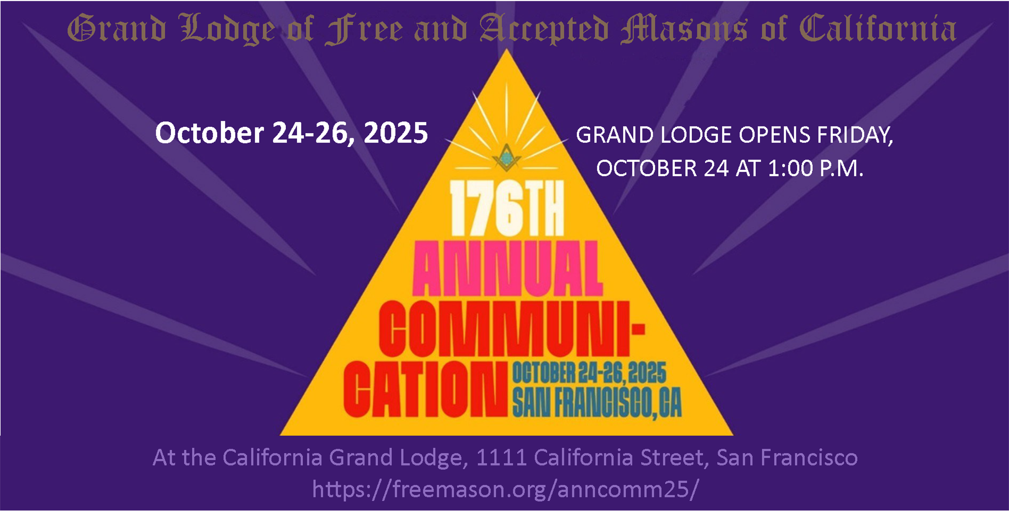**OCTOBER 2025**

**MASONIC BIRTHDAYS**

**HAPPY BIRTHDAY BRETHREN**

|  |  |
| --- | --- |
| **Brother** | **Date Raised** |
| Orlando Arce, PM | 9/30/2009 |
| William Beck, | 9/19/1957 |
| John Cooper III, PGM | 9/10/1964 |
| Robert De Luzuriaga, PM | 9/23/2002 |
| John Echevarria, | 9/20/2017 |
| Emil Estolano, | 9/23/2003 |
| Milorad Golubovich, | 9/12/1967 |
| David Heaton, PM | 9/27/1980 |
| Steven Holly, PM | 9/20/1971 |
| Servillano Modesto Jr., | 9/24/2003 |
| King Man Ng, | 9/14/2016 |
| Paul Pietroski, PM | 9/23/1989 |
| James Robertson III, PM | 9/14/1976 |
| Harry Rogers, | 9/30/1971 |
| Christian Sorensen, | 9/20/1968 |
| Herleiv Storseter, PM | 9/19/1969 |
| Carlos Suncin, | 9/10/2014 |
| George Wade, PM | 9/22/1992 |
| Glen Williams, PM | 9/30/2003 |

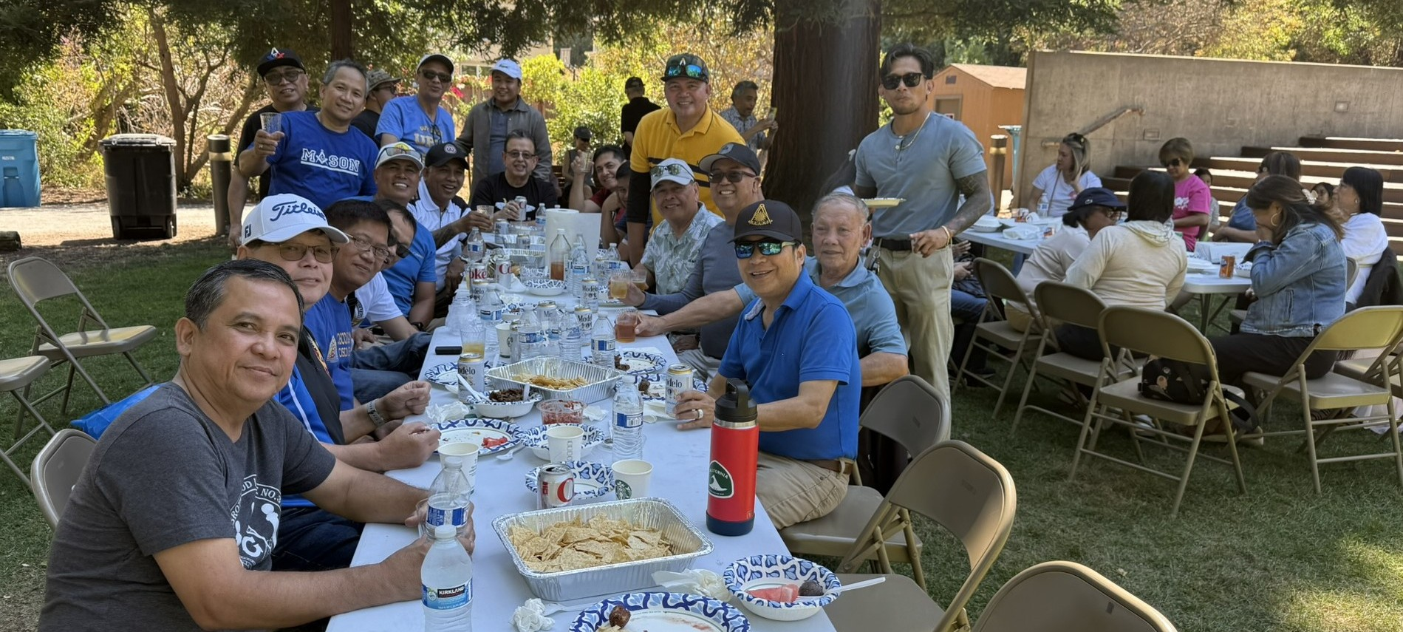

HAVE YOU BEEN LISTENING? TRIVIA

1. Three Core Principles of Freemasonry are **Brotherly love**, Relief, and Truth.
2. The “Circumpunct” has also been referred to as a **Point** in a Circle.
3. Many of our Lodge brothers supported Masons4Mitts on Saturday August 9th to watch the San Francisco Giants play the Washington **Nationals** play ball.
4. Alta Vista Lodge No 464 consolidated with Argonne Lodge No 461 in 1983 to form **Columbia** Lodge No. 461.
5. In Freemason history, the Premier Grand Lodge of England was generally considered to have been founded on **June 24, 1717**.
6. The Lodge of the Goose and **Gridiron** Ale House, the Lodge of the Crown Ale House, the Lodge of the of the Apple Tree Tavern and the Lodge of the Rummer and Grapes Tavern gathered at the Goose and Gridiron Alehouse on June 24, 1717, and declared themselves a Grand Lodge.
7. This Grand Lodge (in # 6 above) was called the **Premier** Grand Lodge of England.
8. [Anthony Sayer](https://thetwocrafts.com/2023/03/13/the-path-to-modern-freemasonry/) was elected the first **Grand** Master of the Premier Grand Lodge of England.
9. The Premier Grand Lodge published the "Constitutions of the Free-Masons" by James Anderson, the first comprehensive rulebook for modern Freemasonry, further solidifying its structure and principles and it was called the **Anderson** Constitutions of 1723.
10. The 1723 edition of the Constitutions was edited and reprinted by Benjamin Franklin in Philadelphia in **1734**, becoming the first Masonic book printed in America.Answers to September 2025 Trivia
11. Three Core Principles of Freemasonry are **Brotherly** Love, relief, and truth.
12. The “Circumpunct” has also been referred to as a **Point** in a Circle.
13. Many of our Lodge Brothers supported Masons4Mitts on Saturday, August 9th to watch the San Francisco Giants play the Washington **Nationals** play ball.
14. Alta Vista Lodge No. 464 consolidated with Argonne Lodge No. 461 in 1983 to form **Columbia** Lodge No. 461.
15. In Freemason history, the Premier Grand Lodge of England was generally considered to have been founded on **June 24, 1717.**
16. The Lodge of the Goose and Gridiron Ale house, the Lodge of the Crown Ale House, the Lodge of the Apple Tree Tavern and the Lodge of the Rummer and Grapes Tavern gathered at the Goose and Gridiron Alehouse on June 24, 1717 and declared themselves a Grand Lodge.
17. This Grand Lodge (in #6 above) was called the Premier Grand Lodge of England.
18. Anthony Sayer was elected the first Grand Master of the Premier Grand Lodge of England.
19. The Premier Grand Lodge published the “Constitutions of the Freemasons” by James Anderson, the first comprehensive rulebook for modern Freemasonry, further solidifying its structure and principles and it was called the Anderson constitutions of 1723.
20. The 1723 edition of the Constitutions was edited and reprinted by Benjamine Franklin in 1734, becoming the first Masonic book printed in America.

**September Cryptogram**

**TRUTH IS A DIVINE ATTRIBUTE**

**AND THE FOUNDATION OF EVERY VIRTUE.**

**TO BE GOOD AND TRUE IS THE FIRST**

**LESSON WE ARE TAUGHT IN MASONRY.**

The coded statement in the September Trestle board has been decoded and is provided in the box to the right.

**October Cryptogram**

The October Cryptogram is provided in the box below, and the decoded statement will be provided in the October Trestle board. Clues for the Cryptogram are: (K = E), (Z = I), (O – T), and the phrase describes a virtue.

**OBEOM ZX Q TZFZFK QOOBZREOK**

**QGT OMK NPEGTQOZPO PN KFKBI FZBOK.**

**OP RK DPPT QGT OBEK ZX OMK NZBXO**

**WKXXPG AK QBK OQEDMO ZD JQXPGBI.**

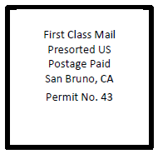

Columbia Brotherhood Lodge #370

855 Brotherhood Way

San Francisco, CA 94132

Important Reminder from the Master

I hope you all had most enjoyable summers that were safe and meaningful for you and your families. Let us move ahead into the fall and winter seasons being mindful of the lessons our Masonic Journeys teach us and to work to remain in that Circumpunct bound by the holy Writings and examples set forth by the Holy Saints John.

May we always meet on the level, act upon the plumb, and part upon the square.

Anil Awasti

Master 2025

[This Photo](https://www.eyeopeningtruth.com/longest-day-litha-summer-solstice-paganism-rising/) by Unknown Author is licensed under [CC BY-NC-ND](https://creativecommons.org/licenses/by-nc-nd/3.0/)